
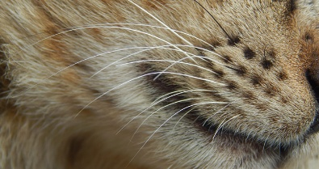
Home Learning Ideas
Paws, Claws and Whiskers

Spring 1
Year 1
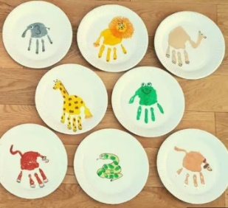
Below are some creative home learning ideas based around our next topic. Please read the ideas to your child and let them choose which activities they would like to complete at home with you or on their own. Try to complete at least 2 activities by the end of the half-term. We would love to see your amazing home learning so make sure you send us photos on dojo or bring it in to school so that it can be shared with your class.

- Create a piece of animal themed artwork. Be as creative as you like (the more adventurous the better!) this could be a collage, a 3D model, a painting or drawing.
- Use information books and the internet to research your favourite animal. Find out do they have paws, claws and whiskers, what they eat and their habitat. Record your findings.
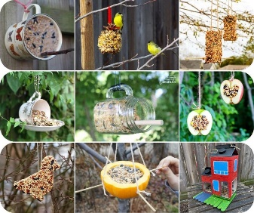
- Choose an animal story to read. Examples include The Tiger Who Came to Tea by Judith Kerr, The Hare and the Tortoise by Brian Wildsmith or How to Hide a Lion by Helen Stephens. Draw a picture of your favourite event in the story. Write a few sentences beneath your picture to explain what is happening.
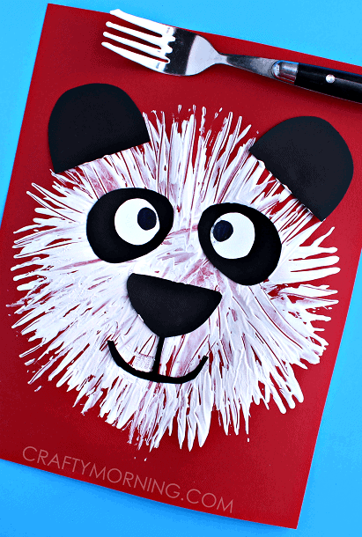
- Look out onto your street, explore your garden and take a walk in your neighbourhood to look for animals. Record the animals that you see in a table. Use the data you have collected to find out which type of animal was the most and least common.
- Make a bird feed and put it in your garden. Can you record the birds you spot eating from the bird feed?
- Make a mask/costume and become your favourite animal.
- Can you create some animal inspired cooking or baking?
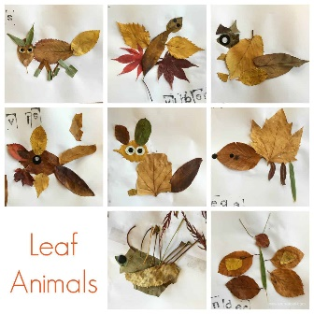
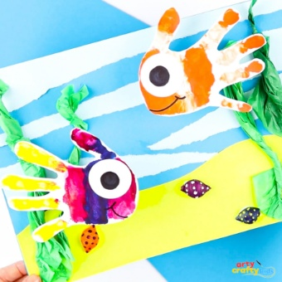
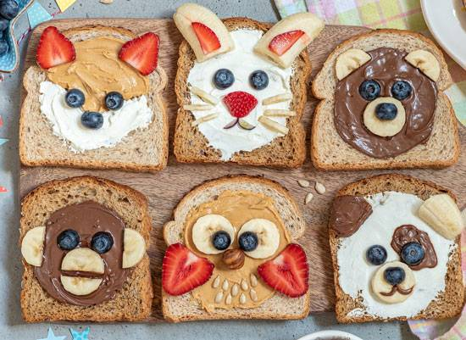
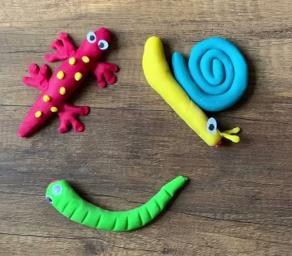
- Can you create a guess who card about an animal?
Don’t worry if your creative home learning doesn’t fit inside your home learning book the more creative and exciting the better.
Have fun and send a Class Dojo to your class teacher if you have any queries regarding home learning activities.
Please ensure that all home learning you would like to share is brought into school by Monday 9th February 2026 so that we have plenty of time to show off your masterpieces.
Thank you for your continued support, it makes such a difference to your child to work together as a 3-way partnership – Parent, Child and Teacher.

