Creative Home Learning Ideas
Once Upon a Time…
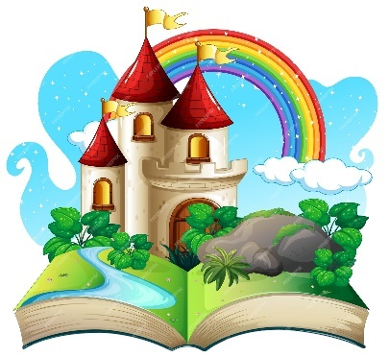
Autumn 2
Year 1

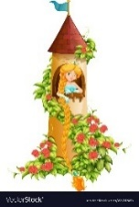
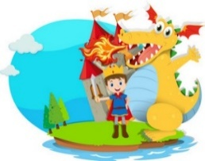

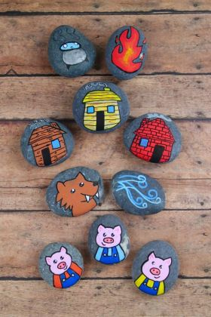
- Can you create story stones or spoons to re – tell your favourite fairy tale with?
- Can you create your own Who am I card by describing your fairy tale character?
- Can you design a Book cover for your own fairy tale?
- Can you create an invitation for a character inviting them to a Royal ball at the castle?
- Can you create a map for Goldilocks to follow into the woods to get to The Three Bears cottage?
- Can you design your own spell like a Wicked Witch or Wizard?
- Create a Gingerbread house for the Gingerbread man.
- Can you build a house for the Three Little Pigs? What materials could you use?
- Can you build a maze using Lego, playdough or straws? Can the knight/dragon find the princess?
- Your favourite fairy tale villain has escaped! Can you create a Wanted poster.
- Can you make some Jam tarts for the Queen of hearts?
- Can you build a Bridge to help the Three Goats get to the greenest grass at the other side of the field?

Don’t worry if your creative home learning doesn’t fit inside your home learning book, the more creative and exciting, the better. Have fun and send a Class Dojo to any of the Year 1 Team if you have any queries regarding home learning activities.

Please ensure that all home learning you would like to share is brought into school by Monday 15th December 2025, ready for the topic showcase and so that we have plenty of time to show off your masterpieces.
Thank you for your continued support, it makes such a difference to your child to work together as a 3-way partnership – parent, child and teacher.
Below are some creative home learning ideas based around our next topic. Please read the ideas to your child and let them choose which activities they would like to complete at home with you or on their own. Try to complete at least 2 activities by the end of the half-term. We would love to see your amazing home learning so make sure you send us photos on dojo or bring it in to school so that it can be shared with your class.

